# Flowing LED Lights

CIRCUIT DIAGRAM:

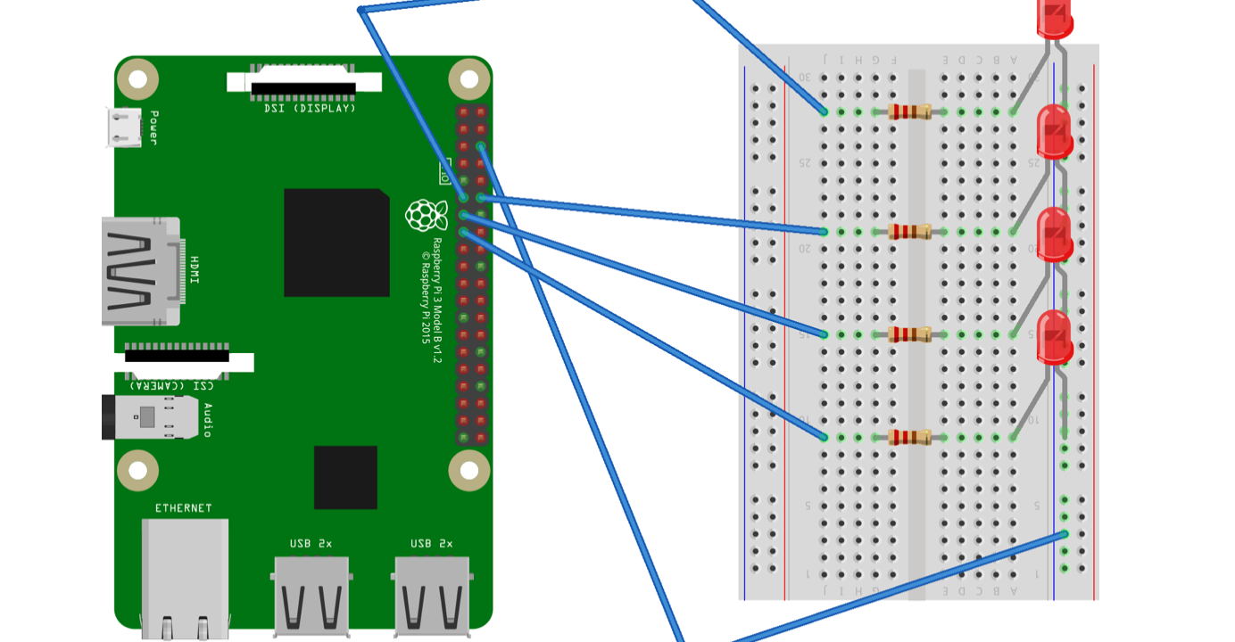

Code:

**import** **RPi.GPIO** **as** **GPIO**

**import** **time**

pins = [11, 12, 13, 15]

GPIO.setmode(GPIO.BOARD) *# to use Raspberry Pi board pin numbers*

**for** pin **in** pins:

GPIO.setup(pin, GPIO.OUT) *# Set all pins mode as output*

**def** setup():

**try**:

loop()

**except** **KeyboardInterrupt**: *# When 'Ctrl+C' is pressed, the child program destroy() will be executed.*

destroy()

**def** loop():

**while** **True**:

**for** pin **in** pins:

GPIO.output(pin, GPIO.LOW)

time.sleep(0.05)

GPIO.output(pin, GPIO.HIGH)

**for** pin **in** reversed(pins):

GPIO.output(pin, GPIO.LOW)

time.sleep(0.05)

GPIO.output(pin, GPIO.HIGH)

**def** destroy():

**for** pin **in** pins:

GPIO.output(pin, GPIO.HIGH)

GPIO.cleanup() *# Release resource*

setup()